Project Design Phase
Problem – Solution Fit Template

Date | 30 September 2026
Team ID | SWTID-2026-8886
Project Name | Implement Client Script and UI Policy for Incident
Maximum Marks | 2 Marks

Problem – Solution Fit Template:
The Problem-Solution Fit simply means that you have found a problem with your customer and that the solution you have realized for it actually solves the customer’s problem. It helps entrepreneurs, marketers and corporate innovators identify behavioral patterns and recognize what would work and why
Purpose:
- Solve complex problems in a way that fits the state of your customers.
- Succeed faster and increase your solution adoption by tapping into existing mediums and channels of behavior.
- Sharpen your communication and marketing strategy with the right triggers and messaging.
- Increase touch-points with your company by finding the right problem-behavior fit and building trust by solving frequent annoyances, or urgent or costly problems.
- Understand the existing situation in order to improve it for your target group.

Template:
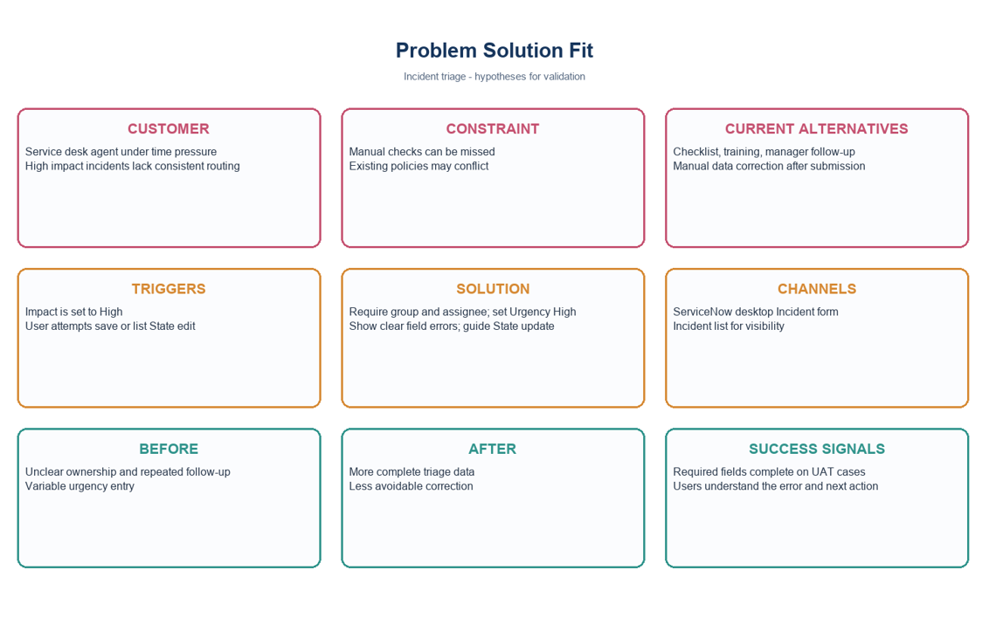
References:
- https://www.ideahackers.network/problem-solution-fit-canvas/
- https://medium.com/@epicantus/problem-solution-fit-canvas-aa3dd59cb4fe
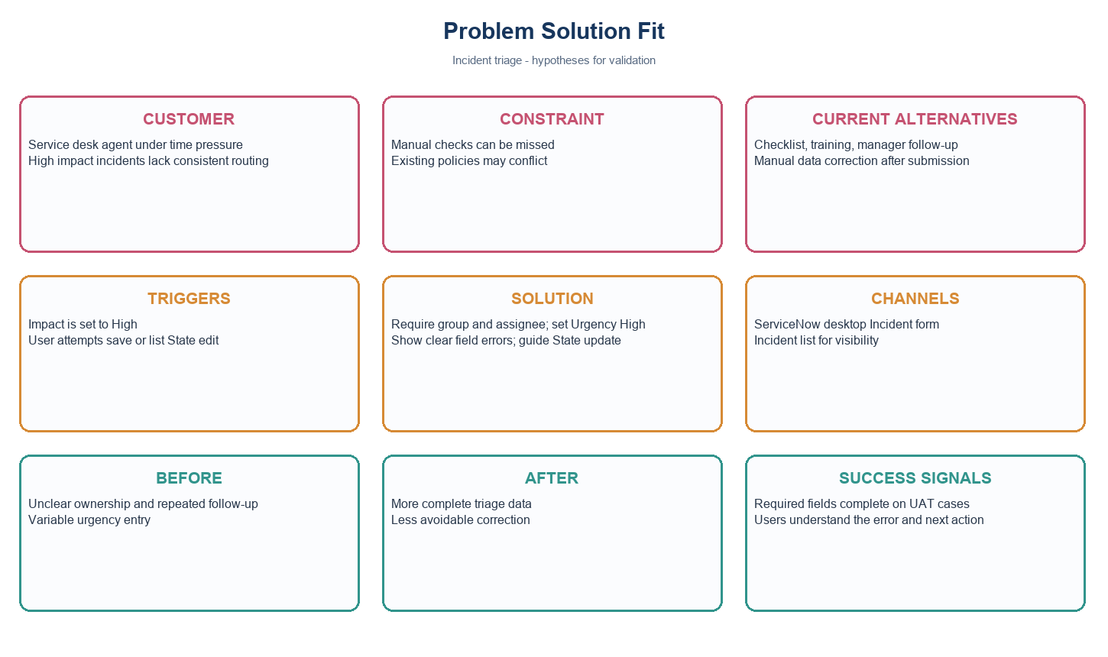
Problem solution fit canvas for Incident triage
Hypothesis | How to validate
Agents miss routing fields on high-impact records. | Review sample records and run UAT with service desk users.
Automatic urgency and clear errors improve triage. | Observe form completion and collect user feedback.
List State edits should be limited. | Confirm with the service owner before enabling.
Project note: values use the standard Incident choices where Impact 1 and Urgency 1 represent High. Confirm field names and values in the target instance.

